## Mengzhou Yao

## 08/11/2020

## IT FDN 110 A

## Assignment06

<https://github.com/myao3/IntroToProg-Python-Mod06>

**To do List Script**

**Introduction**

In this assignment 06, the script will display a list of menu to the user: Show current data; Add a new item; Remove an existing item; Save Data to File; Exit Program under the def function.

**Procedure**

Script Title

Before creating the script, we must create script title as always.

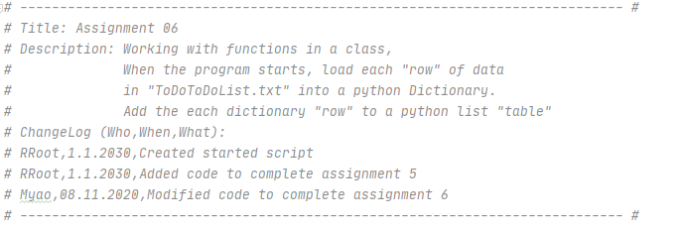

*Figure 1: the screenshot of Script Title in the PyCharm program*

Creating Script

There are three sections in the script: class Processor, class IO, and main body.

Under add_data_to_list function, I add two user inputs, display those two inputs in the dictionary row, and add them to the end of the list.

Under remove_data_to_list function, I add one user input and for loop. In the loop, I use if task is equal to the user input, the user input is removed. If not, no item is removed.

Under write_data_to_list function, I open the file, use ‘for loop’, save the dictionary row into the txt.file, and close the file.

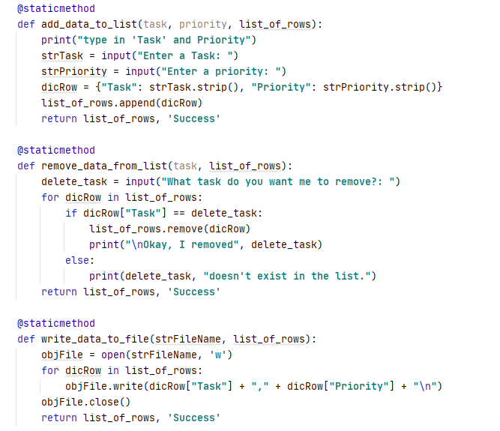

*Figure 2: the screenshot of the* class Processor *in the PyCharm program*

Under input_new_task_and _priority function, I add add_data_to_list function in the class Processor.

Under input_task_to_remove function, I add remove_data_from_list fuction in the the class Processor.

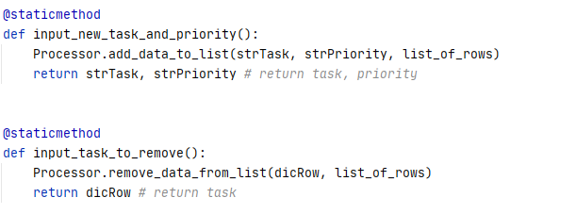

*Figure 3: the screenshot of the class IO in the PyCharm program*

In the main body, if the user choose option 1, the user enters task and its priority under def function (input_new_task_and_priority function). If the user choose option 2, the user removes an existing task from the list under def function ( input_task_to_remove function).

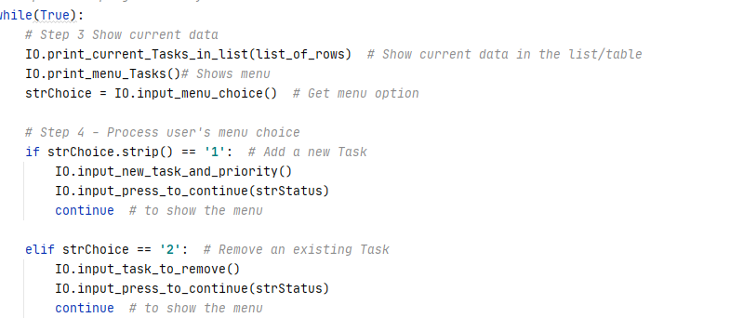

*Figure 4 : the screenshot of the main body in the PyCharm program*

if the user choose option 3, the user select ‘yes’ and saves data to file under def function (write_data_to_file function). If the user choose option 4, the user select ‘yes’ and the clears the current list and reload the data from the txt.file under def function ( read_data_from_list function). If the user choose option 5, the user will exit the program.

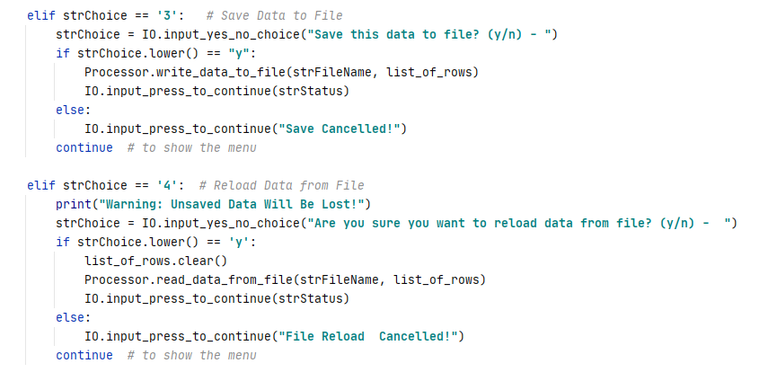

*Figure 4 : the screenshot of the main body in the PyCharm program*

Saving the script

I create a folder in C:\_PythonClass called “Assignment06” and save my script as “Assigment06”.

Running the script

I open PyCharm in search windows and open the “Assignment06” to run module, I choose “1” to enter new task and its priority. I choose “2” to remove an existing task. I choose “3” to sav data to file. I choose “4” to reload the data from file. I choose “5” to exit program.

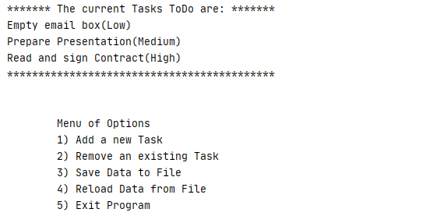

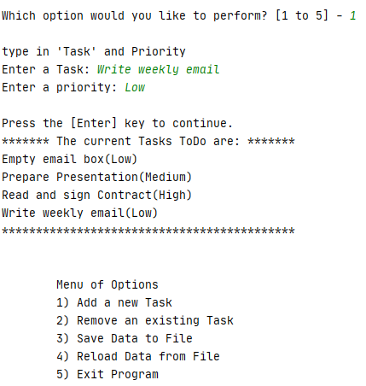

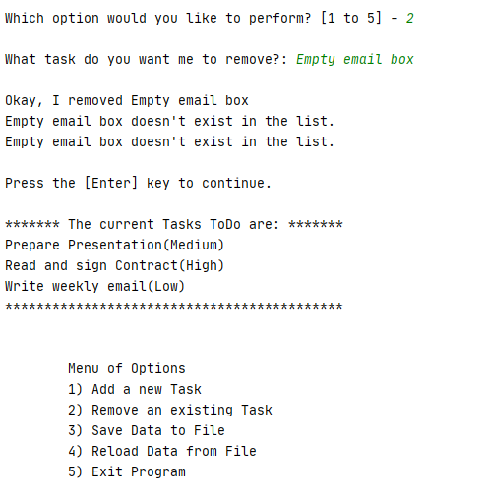

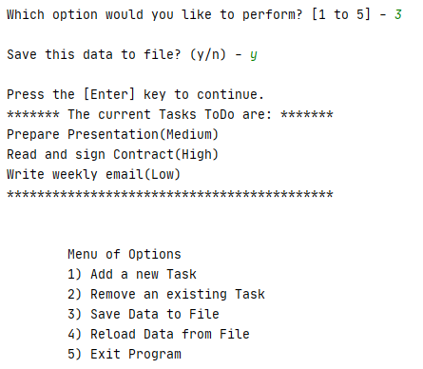

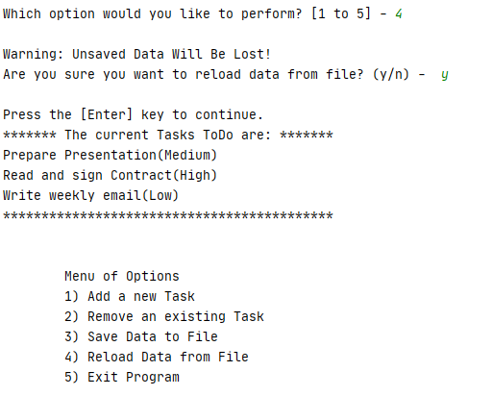

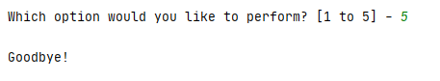

*Figure 5: the screenshot of running the script in the PyCharm program*

Verifying data in the txt.file

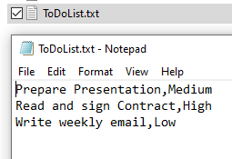

*Figure 6: the screenshot of verifying data in the txt file*

**Summary**

Using the module 06 video, notes, textbook, and supplemental video, I was able to add code in the to do list script by letting user to display the data, enter the data, remove the data, save the data and exit the program under def function.